MACH4METAL

metalworking machinery
Transito 21,
6909 DA BABBERICH, Netherlands
Tel. + 31 (0)316 – 247123
Fax. + 31 (0)316 - 247956
info@mach4metal.com
www.mach4metal.com

Bank No : 66.52.13.883
IBAN : NL33 INGB 0665 2138 83
BIC : INGBNL2A

IEPCO Peenmatic micro blasting
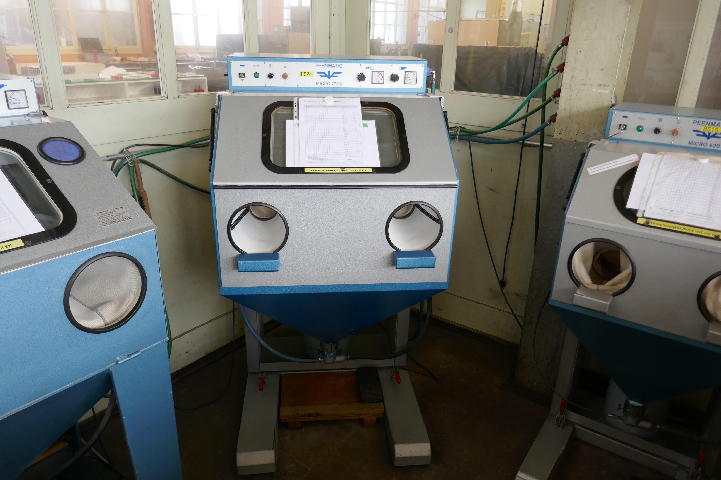
- Make : Iepco Swiss
- Type : Peenmatic 750 S
- YOP : 2000
- No. : 750 - 2184

- Working internal space

- Length : 740
- Width : 520
- Height : 500
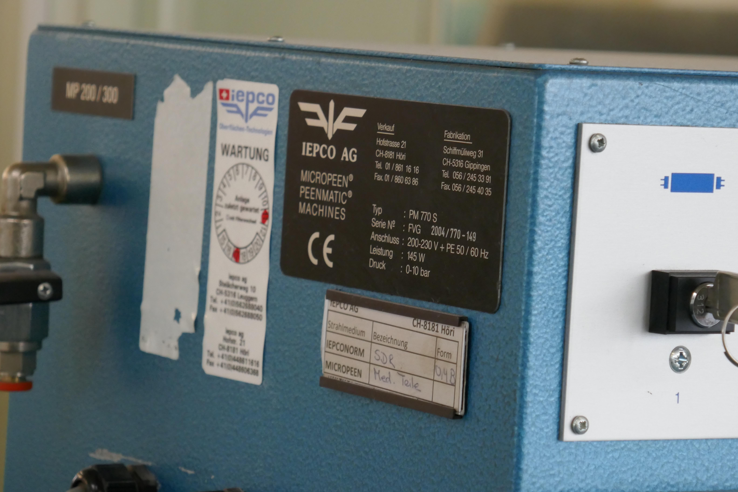
- Optimal product 500 x 400 x 250 mm

- Dimensions outside

- Length : 870
- Width : 936
- Height :1.740

- Door size 360 x 290 mm
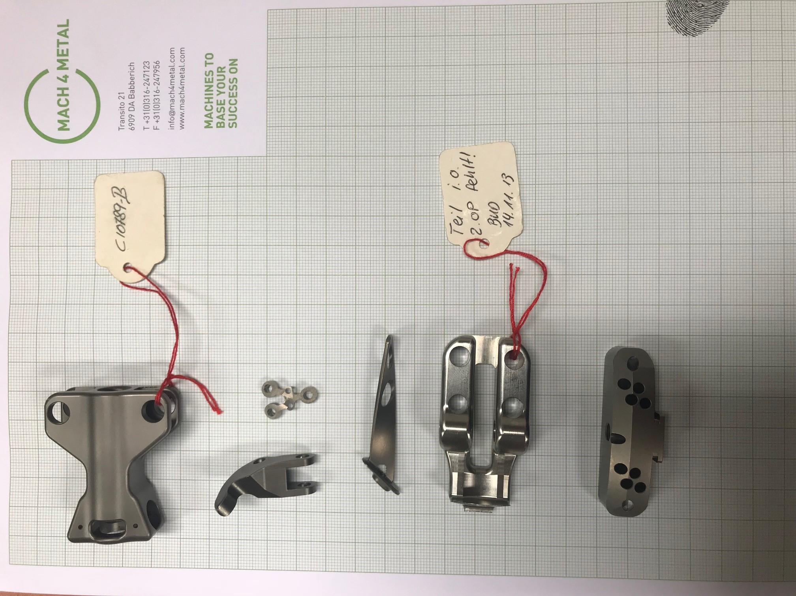

- Blasting gun EF 3 0 – 8 Bar

- Radius arm 275 mm height 115

- Incl. filtration system 1000 mm²
- Pneumatic connection 1/4G
- Electric 230 V / 50/60 HZ
- Weight 205 Kg
- New EUR 8000

Please Note: The above information has been obtained to the best of our ability and belief from, and from the manufacturers where possible. It is given in good faith, but its accuracy can not be guaranteed. Accordingly, it will not form a representation or constitute contractual terms. We advise you to check any vital details!

